Portfolio Documentation

Shenhao

1. **Responsive design**

Mobile view: Width less than 500px

Tablet view: Width from 500 to 970px

Larger screen view: width larger than 970px

**The navigation differs on all three views.** For mobile view, it is vertically aligned because horizontal space is not enough. For tablet and larger screen view, it is horizontally aligned but at different position. For tablet view it covers the whole width, but for larger screen it covers the right side of the screen.

**The media query causes structural changes to all five pages.** Generally, in mobile phone, I aligned <div> horizontally in a single column. In tablet view and larger screen view, I spread things out using grid and flexbox. In this way, the div won’t become too short or too thin in these two views.

**Reduced motion media query:** The reduced motion media query will take away the animation of the “skip to main content” button and the photo gallery. It will also hide the rolling mouse on every page.

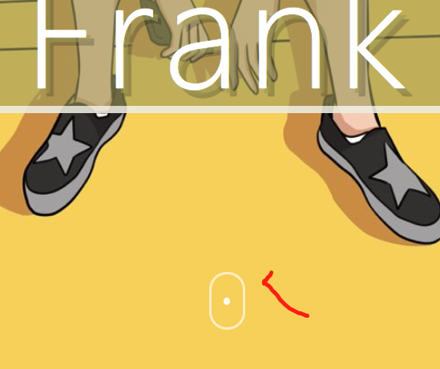

**Use of grid:**

* **Homepage: photo navigation**

I use grid here because I’m sure I want a 4rows layout for mobile and tablet view and I want a 2 by 2 layout for the larger screen view.

* **“Portfolio” page: “Working process” section**

I use grid here because I’m sure I want a 6-row layout for mobile view and 3 by 2 layout for tablet and large screen view. Also, I want the two photo galleries on different columns.

**Use of flexbox:**

* **“About me” page: textbox**
* **“Resume” page: “Skills developed” and “My course” part**

I use flexbox because these are all basically just textbox and there isn’t a big difference. So, I don’t have a preference of the layout and I just used flexbox and see what it is giving me.

**CSS animation:**

1. Skip to content button
2. Rolling mouse on each page
3. Photo gallery effect

**Gallery:**

On “Portfolio” page

**Challenge problem:**

1. Parallax image: on every page
2. Flip card: on large screen view of “About me” page
3. Google analytics: added
4. Photo gallery effect: added
5. Use the Retro shadow effect for the intro of every page

